Best Database Options to Use with FlutterFlow (Firebase vs Supabase vs APIs like Xano)
When building apps with FlutterFlow, selecting the right backend is a critical decision. It directly affects real-time performance, scalability, development speed, and long-term maintainability.
This guide covers the most commonly used backend options:
● Firebase (Google Backend-as-a-Service)
● Supabase (Open-source Firebase alternative)
● API-based backend such as Xano
Then we’ll compare them and explain why Firebase is often the most suitable option for FlutterFlow applications.
1. Firebase (Google
Backend-as-a-Service)
Google Firebase is the most widely adopted backend for FlutterFlow due to its native integration and serverless architecture.
Key Features
● Firestore (NoSQL database)
● Real-time data synchronization
● Authentication system
● Cloud Functions for server-side logic
● Cloud Messaging for push notifications
● Cloud Storage for files
How Firebase Works with FlutterFlow
FlutterFlow App
↓
Firebase SDK
↓
Firestore / Authentication / Functions
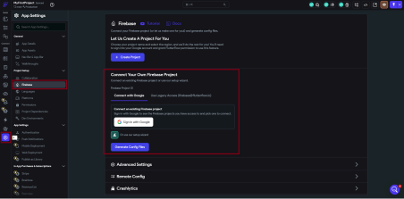
● Firebase integration settings in FlutterFlow
● Firestore collection setup screen
Advantages of Firebase
● Native FlutterFlow integration with minimal setup
● Real-time database updates without additional configuration
● Strong mobile-first ecosystem
● Fully serverless and auto-scaling infrastructure
● Built-in authentication system
● Integrated push notification support via FCM
Limitations of Firebase
● NoSQL structure can be restrictive for complex relational data
● Costs can increase with inefficient queries or high usage
● Strong dependency on Google ecosystem
2. Supabase (Open-source Firebase Alternative)
Supabase is an alternative backend built on PostgreSQL, offering a relational database approach. Key Features
● PostgreSQL relational database
● Real-time subscriptions
● Authentication system
● File storage
● Edge functions for server-side logic
How Supabase Works with FlutterFlow
FlutterFlow App
↓
Supabase API Layer
↓
PostgreSQL Database
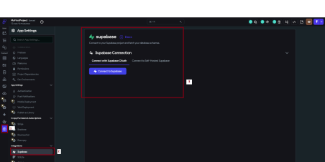
● Supabase API key configuration in FlutterFlow
● Table editor in Supabase dashboard
Advantages of Supabase
● SQL-based relational database model
● Open-source and self-hostable
● Strong support for structured and relational queries
● Real-time updates through subscriptions
Limitations of Supabase
● Less native integration with FlutterFlow compared to Firebase
● Requires manual API configuration
● Smaller ecosystem and fewer mobile-first features
3. API-Based Backend (Xano Example)
Xano is a no-code backend solution that provides API-driven architecture with built-in database and logic.
Key Features
● Auto-generated REST APIs
● PostgreSQL database
● Visual backend logic builder
● Authentication system
● Workflow automation tools
How Xano Works with FlutterFlow
FlutterFlow App
↓
REST API Calls
↓
Xano Backend
↓
Database + Business Logic
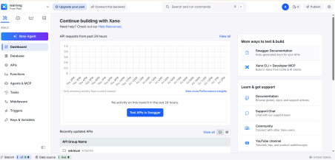
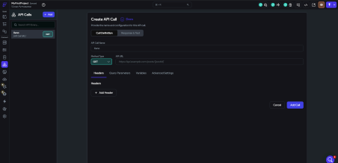
Advantages of Xano
● Highly flexible backend logic
● Works with any frontend framework
● Suitable for complex business rules
● No server management required
Limitations of Xano
● No native real-time functionality by default
● Requires API-based integration effort
● Slightly higher latency compared to direct backend SDKs
● More setup complexity for beginners
4. Firebase vs Supabase vs Xano
(Comparison)
Feature | Firebase | Supabase | Xano
Real-time updates | Very strong | Strong | Limited

FlutterFlow  Integration | Native | Moderate | API-based
Ease of use | Very easy | Moderate | Moderate
Scalability | High | High | High
Database type | NoSQL | SQL | SQL
Push notifications | Built-in | Limited | Manual setup
Server-side functions | Cloud  Functions | Edge  Function  s | Built-in  workflows

5. Why Firebase is Better for
FlutterFlow
Although all three options are capable, Firebase remains the most optimized backend for FlutterFlow development, especially for mobile-first applications.
1. Real-Time Data Synchronization
Firestore provides built-in real-time updates without additional configuration. This is especially useful for:
● Chat applications
● Live dashboards
● Collaborative apps
No polling or manual refresh logic is required.
2. Native FlutterFlow Integration
Firebase is directly integrated into FlutterFlow, which means:
● One-click project setup
● Direct Firestore binding in UI builder
● Automatic schema detection
● Built-in query system inside FlutterFlow
This significantly reduces development time compared to API-based systems.
3. Push Notification Support
Firebase Cloud Messaging enables:
● Device-level push notifications
● Backend-triggered alerts
● User engagement campaigns
4. Server-Side Logic with Cloud Functions Firebase Cloud Functions allow backend logic execution without managing servers. Example flow:
User registration → Cloud Function triggered → Welcome email sent
5. Authentication System
Firebase Authentication supports:
● Email/password login
● Google sign-in
● Apple sign-in
● Phone authentication
6. Scalability and Serverless Architecture Firebase automatically handles:
● Server scaling
● Load balancing
● Infrastructure management
6. Architecture Overview
Firebase Architecture
FlutterFlow
↓
Firebase SDK
↓
Firestore + Authentication + Functions + Messaging
Supabase Architecture
FlutterFlow
↓
API Layer
↓
PostgreSQL Database
Xano Architecture
FlutterFlow
↓
REST API
↓
Xano Backend
↓
Database + Business Logic
Conclusion
Each backend option serves different needs:
● Firebase is best for real-time, mobile-first apps with minimal setup
● Supabase is better for SQL-based relational systems
● Xano is ideal for complex API-driven backend logic
Final recommendation:
For most FlutterFlow applications, especially MVPs and production mobile apps, Firebase provides the best balance of speed, simplicity, and native integration.

